# Minor Project – Shortest Path First

Aditi Singh

Diya Agarwal

Sumit Kr. Rana

# 5.Design all the technical diagram of your projects (Include USE case, Class Diagram, Activity Diagram and Sequence Diagram)

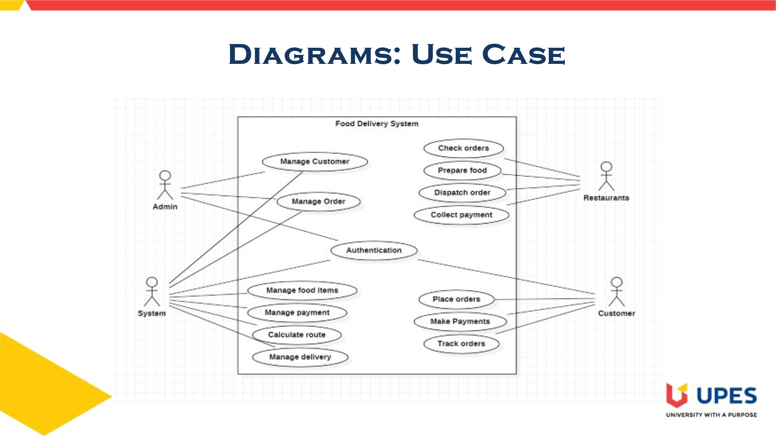

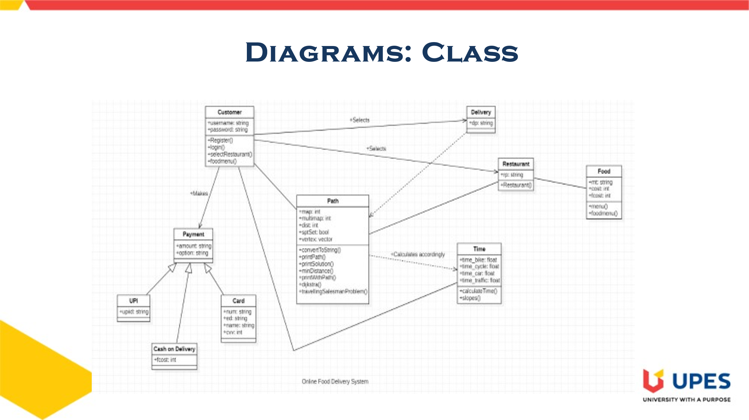

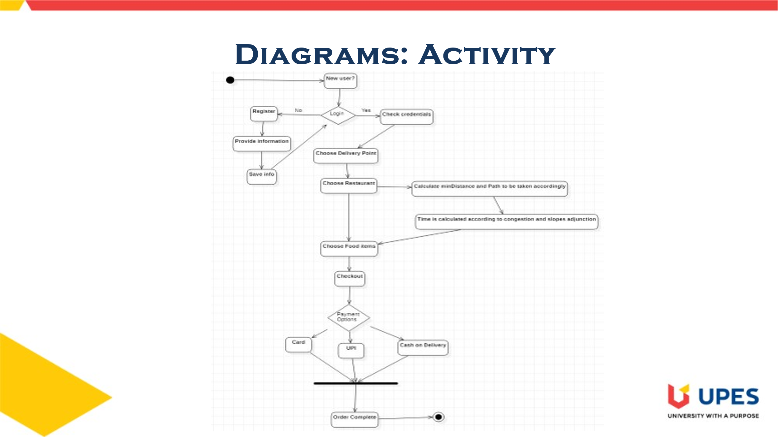

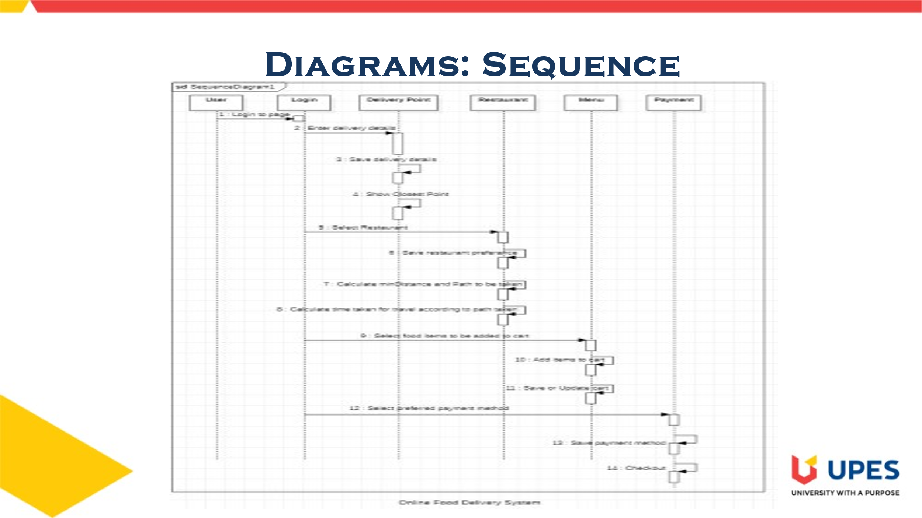

Top of Form

Bottom of Form